## Monetary Policy

Monetary Policy is the setting of the money supply by central bankers.

## Fed Tools-

1. Open Market Operations
   1. Buy bonds🡺The Fed exchanges bonds (pull them out of the economy) for money (put into the economy).
      1. This increases the Money Supply
         1. Increases in Money Supply🡺 Decrease Market Interest Rate🡺Increases Aggregate Demand

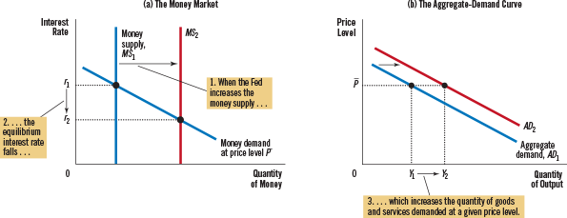

* 1. Sell bonds🡺The Fed exchanges money (out of the economy) for bonds (into the economy)
     1. The decreases the Money Supply
        1. Decreases in Money Supply🡺 Increase Market Interest Rate🡺Decreases Aggregate Demand

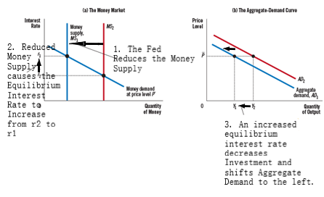

1. Reserve Requirement Ratio (RRR): The portion of deposits that banks must hold on to, i.e. the portion they cannot loan out
   1. Increases in the RRR🡺 banks must hold on to more of deposits—i.e. they can lend out less
      1. This decreases the Money Supply
   2. Decreases in RRR🡺banks hold on to less of deposits—i.e. they lend out more
      1. This increases the Money Supply
2. Discount Window Rate: The rate The Fed charges banks when banks borrow from The Fed
   1. Increases in the Discount Rate🡺Discourage bank lending to consumers
      1. Decreases the Money Supply
   2. Decreases in the Discount Rate🡺Encourages bank lending to consumers
      1. Increases the Money Supply

Fed Tool🡺 Money Supply Changes🡺 Market Interest Rate Changes🡺 Changes in Aggregate Demand=Changes in GDP

Increases in Money Supply🡺 Decrease Market Interest Rate🡺Increases Aggregate Demand

Decreases in Money Supply🡺 Increase Market Interest Rate🡺Decreases Aggregate Demand

## Fiscal Policy

Run by Congress—Controls Government Spending and Taxes

CH 23: AD=C+I+G+NX=GDP

C=Consumption (affected by Tax Rates chosen directly by Congress)

I=Investment (responds to the market interest rate)

G=Government Expenditure (chosen directly by Congress)

NX= Exports-Imports

**Ch: 34-2e**—The Crowding-Out Effect

When Congress Increases government expenditure🡺 Increases in Aggregate Demand

But: This accidently increases Money Demand

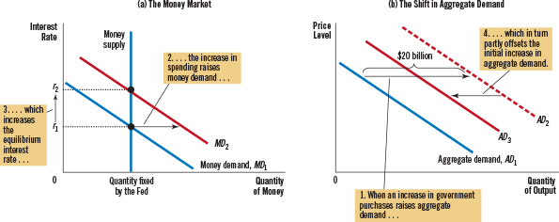

Increases in Money Demand🡺Increases in the Market Interest Rate🡺 Decreasing Private Investment🡺Decreasing Aggregate Demand (somewhat)